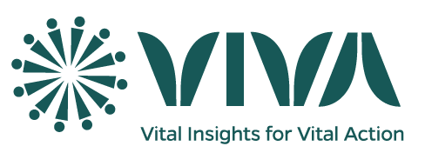**Provincial Level Supervision**

Provincial-level supervision by the Central-level team is a critical component of the program's quality assurance framework. This level of supervision involves direct collaboration between the Central-level team, Provincial focal person, and VASA staff to ensure effective field implementation.

**Pre-Province Visit Preparation:**

Before conducting supervision visits, the Central-level team (Data mangers, analysist and IT staff, focal persons) should:

* Review data reporting trends, identifying clusters with low data submission rates.
* Discuss solutions to address low reporting, considering potential IT-related issues.
* Prioritize clusters for visitation based on the following criteria:
  + Low data reporting
  + Use of paper forms for data collection
  + No visitation in 4+ months

**Supervision of Clusters:**

During supervision visits, the following activities will be conducted:

* Cluster Selection: 15 clusters will be selected for the Central-level team member/Focal person.
* Random Sampling: The data team will randomly select 5 households and 5-10 events in each chosen cluster for supervision activities.
* Field Observation: The Central-level team member/Focal person will accompany a data collector (VASA staff/CSA) during their data collection activities to observe and provide feedback.